TWAS Fellowships for Postdoctoral Research
APPLICATION GUIDELINES

Programme details

TWAS, the academy of sciences for the developing world – www.twas.org – is an autonomous international organization founded in Trieste, Italy, in 1983. TWAS represents the best of science in the developing world. Its principal aim is to promote scientific capacity and excellence for sustainable development in the South. Since 1986, TWAS has been supporting scientists and institutions in developing countries through a wide range of programmes that focus on scientific capacity building largely through South-South cooperation.
The administration and financial operation of TWAS is undertaken by UNESCO in accordance with an agreement signed by the two organizations.
Each year, the TWAS Fellowship Programme, which operates under agreements with governments and national organizations in developing countries – and particularly with partners in Brazil, China, India, Kenya, Malaysia, Mexico, Pakistan andThailand– offers a number of fellowships to young scientists from developing countries to carry out postdoctoral research in countries other than their own. These programme partners include:
National Council for Scientific and Technological Development (CNPq), Brazil
The TWAS-CNPq Fellowship Programme for Postdoctoral Research offers fellowships to young scientists from developing countries (other than Brazil) who wish to pursue postdoctoral research in the natural sciences in Brazil. Duration: minimum of six months to a maximum of twelve months.

Chinese Academy of Sciences (CAS), China
The TWAS-CAS Fellowship Programme for Postdoctoral Research offers fellowships to young scientists from developing countries (other than China) who wish to pursue postdoctoral research in China. Duration: minimum of six months to a maximum of twelve months.

Council of Scientific and Industrial Research (CSIR), India
The TWAS-CSIR Fellowship Programme for Postdoctoral Research offers fellowships to young scientists from developing countries (other than India) who wish to pursue postdoctoral research in newly emerging areas in science and technology for which facilities are available in CSIR laboratories and institutes. Duration: minimum of six months to a maximum of twelve months.

Department of Biotechnology (DBT) of the Ministry of Science and Technology, India
The TWAS-DBT Fellowship Programme for Postdoctoral Research offers fellowships to young scientists from developing countries (other than India) who wish to pursue postdoctoral research in biotechnology at key biotechnology research institutions in India. Duration: minimum of twelve months to a maximum of eighteen months.

S.N. Bose National Centre for Basic Sciences, India
The TWAS-S.N. Bose Fellowship Programme for Postdoctoral Research offers fellowships to students from developing countries (other than India) who wish to pursue postdoctoral research in the physical sciences. Duration: minimum of six months to a maximum of twelve months.

Indian Association for the Cultivation of Science (IACS), India
The TWAS-IACS Fellowship Programme for Postdoctoral Research offers fellowships to young scientists from developing countries (other than India) who wish to pursue postdoctoral research in certain fields of natural sciences, including biological chemistry, condensed matter physics, inorganic chemistry, materials science, non conventional energy, organic chemistry, physical chemistry, polymer science, spectroscopy and theoretical physics. Duration: minimum of six months to a maximum of twelve months.

The International Centre for Insect Physiology and Ecology (icipe), Kenya
The TWAS-icipe Fellowship Programme for Postdoctoral Research offers fellowships to young scientists from developing countries (other than Kenya) who wish to pursue postdoctoral research in the natural sciences, especially focusing on integrated control methodologies for crop and livestock insect pests and other related arthropods, and insect vectors of tropical diseases. Duration: minimum of six months to a maximum of twelve months.
Universiti Sains Malaysia (USM), Malaysia
The TWAS-USM Fellowship Programme for Postdoctoral Research offers fellowships to young scientists from developing countries (other than Malaysia) who wish to pursue postdoctoral research in one of the fields of natural sciences. Duration: minimum of twelve months to a maximum of three years.

National Council on Science and Technology (CONACYT), Mexico
The TWAS-CONACYT Fellowship Programme for Postdoctoral Research offers fellowships to students from developing countries (other than Mexico) who wish to pursue postdoctoral research in one of the fields of natural sciences. Duration: minimum six months and maximum twelve months.

National Centre of Excellence in Molecular Biology (CEMB), Pakistan
The TWAS-CEMB Fellowship Programme for Postdoctoral Research offers fellowships to young scientists from developing countries (other than Pakistan) who wish to pursue postdoctoral research in molecular biology and molecular genetics. Duration: minimum of six months to a maximum of twelve months.

International Center for Chemical and Biological Sciences (ICCBS), Pakistan
The TWAS-ICCBS Fellowship Programme for Postdoctoral Research offers fellowships to young scientists from developing countries (other than Pakistan) who wish to pursue postdoctoral research in organic chemistry, biochemistry, biotechnology, molecular medicine, pharmacology or physical chemistry. Duration: minimum of six months to a maximum of twelve months.

The National Center for Genetic Engineering and Biotechnology (BIOTEC), Thailand
The TWAS-BIOTEC Fellowship for Postdoctoral Research offers fellowships to young scientists from developing countries (other than Thailand) who wish to pursue postdoctoral research in the field of molecular biology, molecular genetics, microbiology, biochemistry, organic chemistry, biotechnology, bioinformatics, or related disciplines. Duration: minimum of twelve months to a maximum of twenty-four months.

Summary of research fields covered by each programme:
Programme | Agricultural sciences | Biology | Chemistry | Earth sciences | Engineering sciences | Mathematics | Medical sciences | Physics
CNPq, Brazil | √ | √ | √ | √ | √ | √ | √ | √
CAS, China | √ | √ | √ | √ | √ | √ | √ | √
CSIR, India | √ | √ | √ | √ | √ | √ | √ | √
DBT, India | √ | √ | √ | √ | - | - | √ | √
SN Bose, India | - | - | √ | - | - | √ | - | √
IACS, India | - | √ | √ | - | √ | √ | - | √
icipe,  Kenya | √ | √ | √ | - | - | - | √
USM, Malaysia | √ | √ | √ | - | √ | √ | √ | √
CONACYT, Mexico | √ | √ | √ | √ | √ | √ | √ | √
CEMB, Pakistan | √ | √ | - | - | - | - | √ | -
ICCBS, Pakistan | √ | √ | √ | - | - | - | √ | -
BIOTEC,  Thailand | √ | √ | √ | - | - | - | √
√ = Fellowships offered in this subject area; - = Fellowships NOT offered in this subject area.

Important notes
Applicants may apply for only one TWAS Fellowship per year. For example, applicants to the TWAS-CAS programme cannot also apply to other TWAS Fellowship programmes with other partners, including those provided through BIOTEC, CEMB, CNPq, CONACYT, CSIR, DBT, IACS, ICCBS, icipe, S.N. Bose, USM and TWAS Fellowships for Research and Advanced Training. Applicants for TWAS Fellowships for Research and Advanced Training should download the relevant application form (see www.twas.org, under 'Programmes' > ‘Exchange’, or request it from fellowships@twas.org).

General information
Please check the eligibility criteria carefully, especially the age restrictions, timing of the start of the Fellowship and deadline for the receipt of applications. See specific 'Additional information' sections for specific information regarding each programme. Remember, you can apply for only one Fellowship programme per year.

• Applicants must be regularly employed in a developing country (other than the one they intend to visit) and hold a research assignment there.
• Applicants already on site in the host country are not eligible.
• Women scientists are especially encouraged to apply.
• International travel (return economy class by the shortest route) and visa expenses will be covered by TWAS.
• Programme partners will provide a stipend to cover living expenses, in some cases including health insurance. If health insurance is not provided by the programme partner, obtaining suitable health insurance is the awardee’s own responsibility and will be at his/her own expense.
• All specific obligations, regulations, stipends etc will be thoroughly explained to successful candidates in the award letter/contract.
• Applicants must provide evidence that they will return to their home country upon completion of their Fellowships.
• Applicants must submit an official Acceptance Letter from the host institution (see sample on page 5) to TWAS (in all cases) and to the relevant programme partner organization (except in the case of S.N. Bose, India; CONACYT, Mexico and ICCBS, Pakistan) when applying, or by the deadline at the latest.
• The Fellowships do not include provisions for accompanying family members.
• Applications for part-time Fellowships will be considered ineligible.
• Incomplete/unsigned applications will not be accepted. This also applies to submissions by fax and electronic mail, which must include all enclosures and be signed (either digitally or by including a scanned signature).
• Successful applicants must not take up other assignments during the period of their Fellowships.
• Applications will be acknowledged once they have been processed.
• Successful candidates will be notified by February of the year following the application.
• TWAS shall be entitled to a repayment of all or part of any funds paid to an applicant hereunder, in the event that the applicant intentionally or negligently fails to fulfil any or all of the present conditions. The applicant agrees to pay any reasonable legal and/or collection costs incurred by TWAS to obtain the repayment.

Deadlines for receipt of applications
For all programmes, the call for applications is open from 1 March of each year until the deadlines indicated below.

30 June | 31 August | 15 September
CNPq, Brazil | CAS, China | icipe, Kenya
IACS, India | CSIR, India | USM, Malaysia
CONACYT, Mexico | DBT, India | BIOTEC, Thailand
CEMB, Pakistan | S.N. BOSE, India
ICCBS, Pakistan
STEP BY STEP GUIDELINES ON HOW TO APPLY

It is important to note that applicants cannot apply for fellowships tenable in their home country, for instance an Indian applicant applying for a fellowship tenable in India will be considered ineligible. The same applies to applicants already in the host country.
In order to apply for a TWAS Fellowship, each applicant is requested to follow a few key steps that are indicated below:

1. WHICH PROGRAMME SHOULD I CHOOSE?
You should carefully read the “General information” and “Additional information” sections in these application guidelines and choose the most suitable fellowship for your research needs.
2. CHECK ELIGIBILITY CRITERIA:
After choosing a fellowship programme, you should verify that you are eligible and meet ALL the eligibility criteria specified in the “additional information” section of your chosen programme (e.g. age, nationality etc.).

3. CHOOSE AN ELIGIBLE HOST INSTITUTE:
Select a suitable host institution under the fellowship you have chosen. In these guidelines, under “additional information”, you will find the website addresses leading to the lists of eligible host institutes for each programme.

4. GET PRELIMINARY ACCEPTANCE:
Applying is subject to preliminary acceptance at a host institute. After choosing an eligible host institute, you must seek to obtain preliminary acceptance and an Acceptance Letter (see sample on page 5). To request an Acceptance Letter you must contact the chosen host institution via e-mail, fax or by sending a letter with your CV, research proposal and the sample copy of the Acceptance Letter. This must indicate a starting date in the year following the application, for instance if applying in 2011, the letter must indicate 2012 as the starting date.
Obtaining preliminary acceptance at an eligible host institute is the responsibility of the applicant.
For specific information on how to obtain an Acceptance Letter and who to contact in this regard, please refer to the “additional information” section of each specific fellowship programme.
Applications will not be considered or processed without the Acceptance Letter from a host institution.

5. SUBMIT THE APPLICATION:
Once the Acceptance Letter has been received, you should submit to the TWAS Fellowships Office (fellowships@twas.org) and to the other programme partner (in specified cases) the completed application form by e-mail (as MS Word file) together with ALL the required enclosures in one zipped (compressed) electronic file. Alternatively, applications can be submitted by fax or by post.
You are advised to apply for the Acceptance Letter well in advance so that there is sufficient time for you to collate all required documents for submission by the deadline.
No documents are accepted after the deadline. Incomplete applications will not be considered.
An official acknowledgment will be sent confirming the status of your application once it has been processed and not upon receipt.
If awarded, the fellowship must be taken up in the year following the application.

SAMPLE ACCEPTANCE LETTER FOR HOST INSTITUTIONS

It is important to note that applicants MUST already be accepted by a host institution in Brazil, China, India, Kenya, Malaysia, Mexico, Pakistan or Thailand to be eligible for a TWAS Postdoctoral Fellowship.
How to obtain the preliminary acceptance letter:
- Identify a suitable host institution from the lists provided (see “additional information” sections).
- Contact your selected host institution or a potential host supervisor, providing your CV, research proposal and a copy of the sample acceptance letter (see below).
Signed acceptance letters must be sent to TWAS and the relevant programme partner (except in the case of S.N. Bose, India; CONACYT, Mexico and ICCBS, Pakistan). The head of department or programme partner’s contact person (as specified in the guidelines for each specific fellowship programme) at the HOST institution must sign the letter. Informal communication exchanged with potential host supervisors can be submitted, but it will not be considered as formal evidence of institutional acceptance.

HOST INSTITUTION'S LETTERHEAD

Department’s name
Institutional address
Tel and fax numbers
E-mail address

[Place and Date]

Dear _______________ [candidate’s name and surname] - _________ [country of citizenship],

This is to inform you that, as a candidate for a postdoctoral fellowship under the agreement established by TWAS and _______________ [programme partner], you have been accepted for a _______________ [length of time in months please specify*] postdoctoral programme in __________ [field of specialization/academic programme], at this department/institution.

If subsequently selected for a TWAS-_______________ [programme partner] Fellowship, you should begin your studies/research in the __________ [month and year following year of application] and expect to conclude by ___________ [month and year]. While researching at this institution, you will be under the supervision of Professor _____________ [name and surname of supervisor] to be contacted at ____________________________ [email address]. The topic for which you have been accepted to study at this institution is: __________________________________________________.

Yours sincerely,

____________________________________
Signature and name of head of department or programme partner’s contact person (as specified in these guidelines for each specific fellowship programme)

N.B. The letter cannot be accepted without a signature.

* Please verify the minimum and maximum duration of the postdoctoral programme in these application guidelines (under the “additional information” section of each programme partner).

IMPORTANT NOTE:
The starting date on the acceptance letter must be the year following the application e.g. If you apply for a fellowship in 2011 the acceptance letter should show the starting date as 2012.
Additional information: TWAS-CNPq, Brazil
TWAS-CNPq Postdoctoral Fellowship Programme
Deadline for receipt of applications: 30 June
Programme Details
- TWAS-CNPq Postdoctoral Fellowships are tenable at research institutions in Brazil for a minimum period of six months to a maximum period of twelve months. They are awarded to scientists from developing countries (other than Brazil) to enable them to pursue postdoctoral research in the natural sciences.
- For the complete list of eligible institutions/programmes (CAPES-Conceito 5, 6 and 7) under CNPq, refer to the worksheet that you can view and download from: http://twas.ictp.it/prog/exchange/fells/fells-pdoc/bra-pdoc or download directly here: CAPES_inst_2010_5-6-7.
- CNPq will provide a standard monthly allowance which should be used to cover living costs, such as accommodation, food and health insurance. The monthly stipend will not be convertible into foreign currency.
- Information about living conditions, such as possibilities of accommodation, transportation, and any other issues related to the candidate’s stay in Brazil must be obtained locally, directly from the host institution. Neither TWAS nor CNPq can provide this information.
- The research activities are developed in Portuguese in most institutions, but communication will be mainly in English.
Eligibility
Applicants for these fellowships must meet the following criteria:
- be a maximum age of 45 years on 31 December of the application year;
- be permanent residents in a developing country (other than Brazil);
- hold a PhD degree in a field of the natural sciences;
- be a regular employee in a developing country (other than Brazil) and hold a research assignment there;
- provide evidence that s/he will return to her/his home country on completion of the fellowship;
- not take up other assignments during the period of her/his fellowship;
- provide an official acceptance letter from the host institution (see sample Acceptance Letter on page 5). Only CAPES-listed (levels 5, 6 or 7) Brazilian institutions are eligible (see point 2 above);
- prove knowledge of Portuguese or provide a certificate of proficiency in Spanish or English (if these languages are not the candidate's mother tongue);
- have an updated Curriculum Vitae on CNPq’s Lattes Platform (see note on online applications below);
- present a detailed research plan agreed by her/his host supervisor;
- be financially responsible for any accompanying family members.
Submitting your application
The call for applications is open from 1 March until 30 June of each year. No applications will be accepted after this date. Therefore, it is recommended to submit your electronic application as early as possible.
- From 2010, all applications to the TWAS-CNPq Fellowships programmes must be submitted online only. The call for applications where you will find the programme details, eligibility criteria, required documents and certificates as well as the online application form is available at www.cnpq.br/editais/ct/2011/twas.htm. Applicants must be aware that CNPq and TWAS will not accept applications submitted by any other means except via the online application form.
- Incomplete applications are not accepted by the online system. Please ensure you have all necessary documents ready for uploading before applying.
- Queries concerning the call for applications to the TWAS-CNPq Fellowships programmes should be directed to: twas.ascin@cnpq.br.

Contact Details
TWAS Fellowships Office  ICTP campus, Strada Costiera 11  34151 Trieste, Italy  Tel: +39 040 2240 314  Fax: +39 040 2240 689  E-mail: fellowships@twas.org | National Council for Scientific and Technological Development - CNPq  International Cooperation Office - CNPq/ASCIN  SHIS Quadra 01 Conjunto B - Bloco D - 1o. andar - Edificio Santos Dumont - Lago Sul - Brasilia, DF, CEP: 71605-001, Brazil  Tel: +55 61 3211- 9440  Fax: +55 61 3211 9442  E-mail: twas.ascin@cnpq.br
Additional information: TWAS-CAS, China

TWAS-CAS Postdoctoral Fellowship Programme
Deadline for receipt of applications: 31 August

Programme Details
- TWAS-CAS Postdoctoral Fellowships in natural sciences are tenable for a minimum period of six months to a maximum period of twelve months at the research institutions of the Chinese Academy of Sciences.
- Eligible CAS institutions: All CAS institutes in China participate in this Fellowship programme. For a complete list please see: www.twas.org.cn and, in particular, english.cas.ac.cn/CASI/.
- CAS will provide a standard monthly allowance which should be used to cover living costs, such as accommodation, food and health insurance. Only emergency medical aid will be available, if needed. The monthly stipend will not be convertible into foreign currency.
- The language of instruction is English.

Eligibility
Applicants for these Fellowships must meet the following criteria:
- be a maximum age of 40 years on 31 December of the application year;
- be nationals of a developing country (other than China);
- hold a PhD degree in a field of the natural sciences;
- be regularly employed in a developing country (other than China) and hold a research assignment there;
- be accepted at a CAS-listed institution participating in the scheme and provide an official acceptance letter from the host institution (see sample Acceptance Letter, page 5). N.B. Requests for acceptance must be directed to the chosen CAS host institution(s), and NOT to CAS headquarters;
- provide evidence of proficiency in English or Chinese.

Submitting your application
The call for applications is open from 1 March until 31 August of each year.
- Applicants should submit the acceptance letter from a CAS institution to CAS headquarters (see contact details below) and TWAS when applying or by the deadline at the latest. Without preliminary acceptance, the application will not be considered for selection.
- Reference letters: Referees must send SIGNED letters as attachments via e-mail directly to TWAS and CAS. The subject line must contain: CAS/PDoc/ candidate’s surname. Alternatively, letters should be sent by post in sealed envelopes. Only signed reference letters can be accepted.
- Applicants to the TWAS-CAS Postdoctoral Fellowship Programme should send their application to TWAS and CAS (by post, fax or email).

CONTACT DETAILS
TWAS Fellowships Office  ICTP campus, Strada Costiera 11  34151 Trieste, Italy  Tel: +39 040 2240 314  Fax: +39 040 2240 689  E-mail: fellowships@twas.org | TWAS Regional Office, Beijing  Bureau of International Cooperation  Chinese Academy of Sciences (CAS)  52 Sanlihe Road  100864 Beijing, China  Tel: +86 10 6859 7220  Fax: +86 10 6859 7543  E-mail: sqfu@cashq.ac.cn

Additional information: TWAS-CSIR, India

TWAS-CSIR Postdoctoral Fellowship Programme
Deadline for receipt of applications: 31 August

Programme details
- TWAS-CSIR Postdoctoral Fellowships are tenable in CSIR research laboratories and institutes in India for a minimum period of six months to a maximum period of twelve months.
- Eligible CSIR institutions: Information on CSIR laboratories and institutes can be obtained by following the links from the CSIR homepage (www.csir.res.in). Alternatively, refer to the worksheet that you can view and download from: http://twas.ictp.it/prog/exchange/fells/fells-pdoc/csir-pdoc or download directly here: CSIR institutes and here: CSIR-Centres.doc.
- CSIR will provide a monthly stipend to cover for living costs, food and health insurance. The monthly stipend will not be convertible into foreign currency. In addition, Fellowship awardees are entitled to subsidized accommodation.
- The language of instruction for foreign scholars in CSIR laboratories/institutes is English.

Eligibility
Applicants for these Fellowships must meet the following criteria:
- be a maximum age of 45 years on 31 December of the application year;
- be nationals of a developing country (other than India);
- hold a PhD in one of the fields of science or technology;
- be regularly employed in a developing country (other than India) and hold a research assignment there;
- be accepted at a CSIR laboratory/institution and provide an official Acceptance Letter from the host institution (see sample Acceptance Letter, page 5). N.B. Requests for acceptance must be directed to the chosen CSIR host institution(s), with copy to the CSIR contact person. This will allow CSIR to monitor requests and offer support or assistance in finding suitable host institution(s), if necessary;
- provide evidence of proficiency in English.

Submitting your application
The call for applications is open from 1 March until 31 August of each year.
- Applicants should submit the acceptance letter from a CSIR institution to CSIR and TWAS when applying or by the deadline at the latest. Without preliminary acceptance, the application will not be considered for selection.
- Reference letters: Referees must send SIGNED letters as attachments via e-mail directly to TWAS and CSIR. The subject line must contain: CSIR/PDoc/candidate’s surname. Alternatively, letters should be sent by post in sealed envelopes. Only signed reference letters can be accepted.
- Applications for the TWAS-CSIR Postdoctoral Fellowship Programme should be sent to TWAS and CSIR (by post, fax or email).

CONTACT DETAILS
TWAS Fellowships Office  ICTP campus, Strada Costiera 11  34151 Trieste, Italy  Tel: +39 040 2240 314  Fax: +39 040 2240 689  E-mail: fellowships@twas.org | Mr. Jaipal Singh, Senior Technical Officer  Council Of Scientific & Industrial Research (CSIR)  International S&T Affairs Directorate (ISTAD)  Anusandhan Bhavan - 2 Rafi Marg  New Delhi 110 001, India  Tel: +91 11 2331 6751  Fax : +91 11 2373 9041, 2371 0618  E-mail: jaipal@csir.res.in

Additional information: TWAS-DBT, India

TWAS-DBT Postdoctoral Fellowship Programme
Deadline for receipt of applications: 31 August

Programme Details
- TWAS-DBT Postdoctoral Fellowships are tenable at key biotechnology research institutions in India for a minimum period of twelve months to a maximum period of eighteen months.
- To help candidates in their choice of a suitable host institution a list of biotechnology institutes in India is available for download from: http://twas.ictp.it/prog/exchange/fells/fells-pdoc/dbt-pdoc
- However, candidates are free to choose an Indian biotechnology institution that does not appear on the list.
- DBT will provide a monthly stipend to cover for living costs, food and health insurance. The monthly stipend will not be convertible into foreign currency. In addition, the fellowship holder will receive a house rent allowance.
- The language of instruction is English.

Eligibility
Applicants for these fellowships must meet the following criteria:
- be a maximum age of 40 years on 31 December of the application year;
- be nationals of a developing country (other than India);
- hold a PhD degree in bioscience or biotechnology;
- be regularly employed in a developing country (other than India) and hold a research assignment there;
- be accepted at a biotechnology institution in India (see sample Acceptance Letter, page 5). N.B.Requests for acceptance must be directed to the chosen host institution(s), and NOT to DBT;
- provide evidence of proficiency in English.

Submitting your application
The call for applications is open from 1 March until 31 August of each year.
- Applicants should submit the Acceptance Letter from an Indian biotechnology institution to TWAS when applying or by the deadline at the latest. Without preliminary acceptance, the application will not be considered for selection.
- Reference letter: Referees must send SIGNED letters as attachments via e-mail directly to TWAS. The subject line must contain: DBT/PDoc/candidate’s surname. Alternatively, letters should be sent by post in sealed envelopes. Only signed reference letters can be accepted.
- Applications for the TWAS-DBT Postdoctoral Fellowship Programme should be sent to TWAS and CICS (see contact details below) (by post, fax or email).

CONTACT DETAILS
TWAS Fellowships Office  ICTP campus, Strada Costiera 11  34151 Trieste, Italy  Tel: +39 040 2240 314  Fax: +39 040 2240 689  E-mail: fellowships@twas.org | Dr. (Mrs) Ganga Radhakrishnan FRSC Honorary Director  Centre for International Cooperation in Science (CICS), Formerly CCSTDS  No: 2, Gandhi Mandapam Road  Chennai 600 025, India  Tel: +91 44 24430228  Fax: +91 44 24914543  E-mail : cics2010@vsnl.net

Additional information: TWAS-S.N. Bose, India

TWAS-S.N. Bose Postdoctoral Fellowship Programme
Deadline for receipt of applications: 31 August
Programme Details
- TWAS-S.N. Bose Posdoctoral Fellowships are tenable at the S.N. Bose National Centre for Basic Sciences in Kolkata, India – www.bose.res.in – for studies towards postdoctoral research in the physical sciences for a minimum period of six months to a maximum period of twelve months.
- The Centre carries out the following research activities:
Linear and Non-linear spectroscopy, Ultrafast molecular processes and spectroscopy, Ultrafast dynamics in biological macromolecules and magnetization, Utrafast laser induced processes, Soft condensed matter systems of chemical and biological interests, mesocopic physics, ionic liquids, multi-component liquid mixtures, supercooled melts, supercritical fluids, bio-nano interface, nano-magnetism, magnonic crystals, micromagnetic simulations, Nanomaterials in general, and Physics of Correlated oxides, low dimensional systems, magnetic shape memory alloys, dilute magnetic semi-conductors, multi-ferroic materials, thin films of metals and oxides, electronic, magnetic and structural properties of complex materials, superconductivity, strongly correlated electronic systems, quantum many-body physics, micromagnetic and monte carlo simulation of static and dynamic properties of nanomagnets, theoretical study of thermal conductivity, Ab initio plane wave pseudo-potential calculation, strongly correlated electron systems, electronic structure and transport through nano-materials.
Quantum field theory, mathematical physics, cognitive science, granular physics, non-commutative quantum mechanics, statistical physics, non-linear dynamics, turbulences, lattice gauge theories, representation theory of lie groups and coherent states, quantum optics, black holes, constrained dynamics, quantum gravity, quantum spin systems, collective behaviour and emergent phenomena, explosive percolation, complex networks and critical phenomena.
Cosmology, Relativistic Astrophysics, ionospheric science, Astrochemistry.

- S.N. Bose will provide a monthly stipend to cover living costs, food and health insurance. The monthly stipend will not be convertible into foreign currency. Free on-campus accommodation will be provided.
- The language of instruction is English.

Eligibility
Candidates for these Fellowships must meet the following criteria:
- be a maximum age of 45 years on 31 December of the application year;
- be nationals of a developing country (other than India);
- be regularly employed in a developing country(other than India) and hold a research assignment there;
- hold a PhD degree in physics, mathematics or physical chemistry;
- be accepted by a department of the S.N. Bose National Centre. Requests for acceptance must be directed to the Dean (Academic Programme), S.N. Bose National Centre for Sciences by e-mail (deanap@bose.res.in) (see sample Acceptance Letter, page 5). In contacting the Dean (Academic Programme), applicants must accompany their request for an Acceptance Letter with copy of their CV and a research proposal outline;
- provide evidence of proficiency in English.

Submitting your application
The call for applications is open from 1 March until 31 August of each year.
- Applicants must submit an Acceptance Letter from a department of the S.N. Bose National Centre when applying, or by the deadline at the latest. Without preliminary acceptance the application will not be considered for selection.
- Reference letters: Referees must send SIGNED letters as attachments via e-mail directly to TWAS. The subject line must contain: Bose/PDoc/candidate’s surname. Alternatively, letters should be sent by post in sealed envelopes. Only signed reference letters can be accepted.
- Applications for the TWAS-SN Bose Postdoctoral Fellowship Programme should be sent to TWAS only (by post, fax or email).

CONTACT Details
TWAS Fellowships Office  ICTP campus, Strada Costiera 11  34151 Trieste, Italy  Tel: +39 040 2240 314  Fax: +39 040 2240 689  E-mail: fellowships@twas.org | Dean (Academic Programme)  S.N. Bose National Centre for Basic Sciences  JD Block, Sector 3, Salt Lake City - Kolkata 700098, India  Tel: +91 33 2335 5706  Fax: +91 33 2335 3477  E-mail: deanap@bose.res.in
Additional information: TWAS-IACS, India

TWAS-IACS Postdoctoral Fellowship Programme
Deadline for receipt of applications: 30 June

Programme Details
- TWAS-IACS Postdoctoral Fellowships are tenable at the Indian Association for the Cultivation of Science (IACS) – www.iacs.res.in – for a minimum period of six months to a maximum period of twelve months in the following fields:
- Theoretical physics
- Condensed matter physics
- Spectroscopy
- Materials science
- Non-conventional energy
- Physical chemistry
- Organic chemistry
- Inorganic chemistry
- Biological chemistry
- Polymer science
- IACS will provide a monthly stipend which should be used to cover living costs such as food, accommodation and health insurance. The monthly stipend will not be convertible into foreign currency.
- The language of instruction is English.

Eligibility
Applicants for these Fellowships must meet the following criteria:
- be a maximum age of 40 years on 31 December of the application year;
- hold a PhD degree in a field of natural sciences;
- be nationals of a developing country (other than India);
- be regularly employed in a developing country (other than India) and hold a research assignment there;
- provide an official Acceptance Letter from a department of the Indian Association for the Cultivation of Science (IACS) (see sample Acceptance Letter, on page 5). Requests for acceptance must be directed to the Dean-Administration and Senior Professor Prof. Subrata Ghosh by e-mail (ocsg@iacs.res.in) who will facilitate assignment of a host supervisor. In contacting Prof. Ghosh applicants must accompany their request for an Acceptance Letter with copy of their CV and a research proposal outline;
- provide evidence of proficiency in English.

Submitting your application
The call for applications is open from 1 March until 30 June of each year.
- Applicants must submit an Acceptance Letter from a department of the Indian Association for the Cultivation of Science (IACS) when applying, or by the deadline at the latest. Without preliminary acceptance the application will not be considered for selection.
- Reference letters: Referees must send SIGNED letters as attachments via e-mail directly to TWAS and IACS. The subject line must contain: IACS/PDoc/candidate’s surname. Alternatively, reference letters can be sent by post in sealed envelopes. Only signed reference letters can be accepted.
- Applicants to the TWAS-IACS Postdoctoral Fellowship Programme should send a copy of their application both to TWAS (by post, fax or email) and IACS (hard copy only).

CONTACT DETAILS
TWAS Fellowships Office  ICTP campus, Strada Costiera 11  34151 Trieste, Italy  Tel: +39 040 2240 314  Fax: +39 040 2240 689  E-mail: fellowships@twas.org | Prof. Subrata Ghosh  Dean-Administration and Senior Professor  Dept. of Organic Chemistry  Indian Association for the Cultivation of Science (IACS)  2A&B Raja S.C. Mullick Road, Jadavpur  Kolkata 700 032, India  Fax: +91 33 2473 2805  E-mail: ocsg@iacs.res.in

Additional information: TWAS-icipe, Kenya

TWAS-icipe Postdoctoral Fellowship Programme
Deadline for receipt of applications: 15 September

Programme Details
- TWAS-icipe Postdoctoral Fellowships in natural sciences are tenable for a minimum period of six months to a maximum period of twelve months at icipe.
- Eligible icipe departments: Fellowships are tenable at icipe, www.icipe.org in the Programmes of Animal Health, Human Health, Plant Health, Environmental Health, in the Department of Molecular Biology and Biotechnology, in the Department of Behavioural and Chemical Ecology, in the Department of Entomology, and at the field station of Mbita, Lake Victoria, Kenya.
- icipe will provide a standard monthly allowance which should be used to cover living costs, such as accommodation, food and health insurance. Only emergency medical aid will be available, if needed. The monthly stipend will not be convertible into foreign currency.
- The language of instruction is English.

Eligibility
Applicants for these Fellowships must meet the following criteria:
- Apply for the TWAS-icipe Postdoctoral Fellowship within five years of completion of their PhD qualification;
- be permanent resident in a developing country (other than Kenya);
- hold a PhD degree in a field of the natural sciences;
- be regularly employed in a developing country (other than the host country) and hold a research assignment there;
- provide evidence that s/he will return to their home country on completion of the fellowship;
- not take up other assignments during the period of his/her fellowship;
- be accepted at an icipe department participating in the scheme and provide an official acceptance letter from the head of the department (see sample Acceptance Letter). Requests for acceptance must be directed to Lillian Igweta, Training Officer (see contact details below) by providing a copy of the CV and a research proposal outline;
- provide evidence of proficiency in English;
- be financially responsible for any accompanying family member.

Submitting your application
The call for applications is open from 1 March until 15 September of each year.
- Applicants should submit the acceptance letter when applying or by the deadline at the latest. Without preliminary acceptance, the application will not be considered for selection.
- Reference letters: Referees must send SIGNED letters as attachments via e-mail directly to TWAS. The subject line must contain: icipe/PDoc/candidate’s surname. Alternatively, letters should be sent by post in sealed envelopes. Only signed reference letters can be accepted.
- Applicants to the TWAS-icipe Postdoctoral Fellowship Programme should send their application to TWAS only (by post, fax or email).

CONTACT DETAILS
TWAS Fellowships Office  ICTP campus, Strada Costiera 11  34151 Trieste, Italy  Tel: +39 040 2240 314  Fax: +39 040 2240 689  E-mail: fellowships@twas.org | Mrs. Lillian Igweta, Training Officer  International Centre of Insect Physiology and Ecology (icipe)  Strategic Partnerships & Capacity Strengthening Prog.  Duduville, Kasarani – off Thika Road  P.O. Box 30772-00100 GPO, Nairobi, Kenya  Tel: +254 20 863 2272  Fax: +254 20 863 2001/2  E-mail: ligweta@icipe.org
Additional information: TWAS-USM, Malaysia

TWAS-USM Postdoctoral Fellowship Programme
Deadline for receipt of applications: 15 September

Programme Details
- TWAS-USM Postdoctoral Fellowships are tenable in the departments, institutions and laboratories of the Universiti Sains Malaysia – www.ips.usm.my – for a minimum period of twelve (12) months to a maximum period of three (3) years are awarded to young scientists from developing countries (other than Malaysia) to enable them to pursue advanced research in the natural sciences.
- USM will provide a standard monthly allowance which should be used to cover living costs, such as accommodation, food and health insurance.
- The language of instruction is English.

Eligibility
Applicants for these Fellowships must meet the following criteria:
- be nationals of a developing country (other than Malaysia);
- hold a PhD degree in a field of the natural sciences;
- apply for the fellowship within five years of having obtained a PhD degree in a field of the natural sciences;
- be regularly employed in a developing country (other than Malaysia) and hold a research assignment there;
- provide an official Acceptance Letter from a department, laboratory or institute at USM (see sample Acceptance Letter, page 5). Requests for acceptance must be directed to the Dean, Institute of Postgraduate Studies, USM (Prof. Roshada Hashim: by e-mail twasusm@gmail.com) who will facilitate assignment of a host supervisor. In contacting Prof. Hashim applicants must accompany their request for an Acceptance Letter with copy of their latest CV and a short write-up of research proposal (maximum 3 pages);
- provide evidence of proficiency in English;
- be financially responsible for any accompanying family members.

Submitting your application
The call for applications is open from 1 March until 15 September of each year.
- Applicants should submit the acceptance letter from a USM department/laboratory to TWAS and USM when applying or by the deadline at the latest. Without preliminary acceptance, the application will not be considered for selection.
- Reference letters: Referees must send SIGNED letters as attachment via e-mail directly to TWAS and USM. The subject line must contain: USM/ PDoc/the candidate’s surname. Alternatively, letters should be sent by post in sealed envelopes. Only signed reference letters can be accepted.
- Applicants to the TWAS-USM Postdoctoral Fellowship Programme should send their application to TWAS and USM (by post, fax or email).

Contact Details
TWAS Fellowships Office  ICTP campus, Strada Costiera 11  34151 Trieste, Italy  Tel: +39 040 2240 314  Fax: +39 040 2240 689  E-mail: fellowships@twas.org | Prof. Roshada Hashim  Dean  Institute of Postgraduate Studies  Universiti Sains Malaysia (USM)  11800 Penang, Malaysia  Tel: +60 4 6532 930  Fax: +60 4 6532 931  Email: twasusm@gmail.com

Additional information: TWAS-CONACYT, Mexico

TWAS-CONACYT Postdoctoral Fellowship Programme
Deadline for receipt of applications: 30 June

Programme Details
- TWAS-CONACYT Postdoctoral Fellowships are tenable at eligible institutions of higher education and research in Mexico for a minimum period of six to a maximum period of twelve months and are awarded to young scientists from developing countries (other than Mexico) to enable them to pursue advanced research in the natural sciences and related fields.
- For the complete list of eligible institutions/programmes under CONACYT, refer to the worksheet that you can download from: http://twas.ictp.it/prog/exchange/fells/fells-pdoc/conacyt-pdoc
- CONACYT will provide a standard monthly allowance which should be used to cover living costs, such as accommodation and food.
- CONACYT will also provide a fixed amount for mandatory health insurance coverage.

Eligibility
Applicants for these Fellowships must meet the following criteria:
- be a maximum age of 40 years on 31 December of the application year;
- be nationals of a developing country (other than Mexico);
- hold a PhD degree in a field of the natural sciences;
- be regularly employed in a developing country (other than Mexico) and hold a research assignment there;
- provide an official Acceptance Letter from the host institution (see sample Acceptance Letter, page 5) from an eligible institution in Mexico. N.B. Requests for acceptance must be directed to the chosen host institution(s), and NOT to CONACYT;
- prove knowledge of Spanish or provide a certificate of proficiency in English (if these languages are not the candidate’s mother tongue).

Submitting your application
The call for applications is open from 1 March until 30 June of each year.
- Applicants should submit the acceptance letter from an eligible Mexican host institution to TWAS when applying or by the deadline at the latest. Without preliminary acceptance, the application will not be considered for selection.
- Reference letters: Referees must send SIGNED letters as attachment via e-mail directly to TWAS. The subject line must contain: CONACYT/PDoc/the candidate’s surname. Alternatively, letters should be sent by post in sealed envelopes. Only signed reference letters can be accepted.
- Applicants to the TWAS-CONACYT Postdoctoral Fellowship Programme should send their application to TWAS only (by post, fax or email).

Contact Details
TWAS Fellowships Office  ICTP campus, Strada Costiera 11  34151 Trieste, Italy  Tel: +39 040 2240 314  Fax: +39 040 2240 689  E-mail: fellowships@twas.org | Dr. Luis Humberto Fabila Castillo  National Council for Science and Technology (CONACYT)  CONACYT Fellowships Office  Insurgentes Sur 1582-1er. piso  Col. Crédito Constructor, Benito Juarez  Mexico, D.F., 03940 MEXICO  Tel.& Fax: +52 555 3228 149  E-mail: lfabila@conacyt.mx, twas-conacyt@conacyt.mx
Additional information: TWAS-CEMB, Pakistan

TWAS-CEMB Postdoctoral Fellowship Programme
Deadline for receipt of applications: 30 June

Programme Details
- TWAS-CEMB Postdoctoral Fellowships are tenable at departments of the National Centre of Excellence in Molecular Biology (CEMB) – www.cemb.edu.pk – for a minimum period of six months to a maximum period of twelve months in the following fields: molecular biology, molecular genetics, plant molecular biology or medical molecular biology.
- CEMB will provide a monthly stipend which should be used to cover living costs such as food, accommodation and health insurance. The monthly stipend will not be convertible into foreign currency.
- The language of instruction is English.

Eligibility
Applicants for these fellowships must meet the following criteria:
- be a maximum age of 45 years on 31 December of the year of application;
- be nationals of a developing country (other than Pakistan);
- be regularly employed in a developing country (other than Pakistan) and hold a research assignment there;
- hold a PhD degree in a field of natural sciences;
- provide an official Acceptance Letter from CEMB (see sample Acceptance Letter, page 5). Requests for acceptance must be sent to the Director of CEMB (Prof. Dr. Muhammad Amin Athar: by e-mail director@cemb.pu.edu.pk and camb1@wol.net.pk) who will facilitate assignment of a host supervisor. In contacting Prof. Athar applicants must accompany their request for an Acceptance Letter with copy of their CV and a research proposal outline;
- provide evidence of proficiency in English.

Submitting your application
The call for applications is open from 1 March until 30 June of each year.
- Applicants must submit an Acceptance Letter from CEMB when applying, or by the deadline at the latest. Without preliminary acceptance the application will not be considered for selection.
- Reference letters: Referees must send SIGNED letters as attachments via e-mail directly to TWAS and CEMB and the subject line must contain: CEMB/PDoc/candidate’s surname. Alternatively, letters should be sent by post in sealed envelopes. Only signed reference letters can be accepted.
- Applicants to the TWAS-CEMB Postdoctoral Fellowship Programme should send a copy of their application (by email, fax or post) to TWAS and to CEMB. (For CEMB only: if sending by email or fax, a hard copy must also be submitted by post).

CONTACT DETAILS
TWAS Fellowships Office  ICTP campus, Strada Costiera 11  34151 Trieste, Italy  Tel: +39 040 2240 314  Fax: +39 040 2240 689  E-mail: fellowships@twas.org | Dr. Shaheen N. Khan  Professor  National Centre of Excellence in Molecular Biology (CEMB)  87 West Canal Bank Road, Thokar Niaz Baig  Lahore 53700, Pakistan  Tel: +92 42 529 3148  Fax: +92 42 516 4155, 42 5293 149  Email: camb1@wol.net.pk, director@cemb.edu.pk

Additional information: TWAS-ICCBS, Pakistan

TWAS-ICCBS Postdoctoral Fellowship Programme
Deadline for receipt of applications: 30 June

Programme Details
- TWAS-ICCBS Postdoctoral Fellowships are tenable at the International Center for Chemical and Biological Sciences (ICCBS) – comprising the H.E.J. Research Institute of Chemistry and the Dr. Panjwani Center for Molecular and Drug Research, www.iccs.edu – for a minimum period of six months to a maximum period of twelve months in the following fields: organic chemistry, biochemistry, biotechnology, molecular medicine, pharmacology or physical chemistry.
- ICCBS will provide a monthly stipend which should be used to cover living costs such as food, accommodation and health insurance. The monthly stipend will not be convertible into foreign currency.
- The language of instruction is English.

Eligibility
Applicants for these Fellowships must meet the following criteria:
- be a maximum age of 45 years on 31 December of the year of application;
- hold a PhD degree in a field of natural sciences;
- be nationals of a developing country (other than Pakistan);
- be regularly employed in a developing country (other than Pakistan) and hold a research assignment there;
- provide a certificate of good health from a qualified medical doctor;
- provide an official Acceptance Letter from ICCBS (see sample Acceptance Letter, page 5). Requests for acceptance must be directed to the Director of ICCBS, Prof. M. I. Choudhary by e-mail (hej@cyber.net.pk or pcmd@cyber.net.pk) who will facilitate the assignment of a host supervisor. In contacting Prof. Choudhary applicants must accompany their request for a preliminary acceptance letter with copy of their CV and a research proposal outline;
- provide evidence of proficiency in English.

Submitting your application
The call for applications is open from 1 March until 30 June each year.
- Applicants must submit an Acceptance Letter from ICCBS when applying, or by the deadline at the latest. Without preliminary acceptance the application will not be considered for selection.
- Reference letters: Referees must send SIGNED letters as attachments via e-mail directly to TWAS. The subject line must contain: ICCBS/PDoc/candidate’s surname. Alternatively, letters can be sent by post in sealed envelopes. Only signed reference letters can be accepted.
- Applicants to the TWAS-ICCBS Postdoctoral Fellowship Programme should send one copy of their application to TWAS only (by post, fax or email). Please do not send a copy to ICCBS.

CONTACT Details
TWAS Fellowships Office  ICTP campus, Strada Costiera 11  34151 Trieste, Italy  Tel: +39 040 2240 314  Fax: +39 040 2240 689  E-mail: fellowships@twas.org | Prof. Muhammad Iqbal Choudhary  Director  International Center for Chemical and Biological Sciences (ICCBS)  University of Karachi, Karachi-75270  Pakistan  Tel: +92 21 4824 924, 4824 925  Fax: +92 21 4819 018, 4819 019  E-mail: hej@cyber.net.pk, pcmd@cyber.net.pk

Additional information: TWAS-BIOTEC, Thailand

TWAS-BIOTEC Postdoctoral Fellowship Programme
Deadline for receipt of applications: 15 September

Programme Details
- TWAS-BIOTEC Postdoctoral Fellowships are tenable in BIOTEC and its affiliated research units listed on this website: www.biotec.or.th/biotechnology-en/en/Research-Units.asp for a period of twelve (12) to twenty-four (24) months and are awarded to young scientists from developing countries (other than Thailand) to enable them to pursue advanced research in biotechnology.
- BIOTEC will provide a standard monthly allowance which should be used to cover living costs, such as accommodation and food.
- The language of instruction is English.

Eligibility
Applicants for these Fellowships must meet the following criteria:
  - be nationals of a developing country (other than Thailand);
  - hold a PhD degree in any of the following fields: molecular biology, molecular genetics, microbiology, biochemistry, organic chemistry, biotechnology, bioinformatics, or related disciplines;
- apply for the fellowship within five years of having obtained a PhD degree in a fields of the natural sciences specified above;
  - be regularly employed at a research and/or teaching institution in their home country where they must hold a research assignment;
- provide an official Acceptance Letter from BIOTEC (see sample Acceptance Letter on page 5). Requests for acceptance must be directed to BIOTEC Research Unit Coordination Division (e-mail: rucd@biotec.or.th) who will facilitate assignment of a host supervisor. In contacting BIOTEC, applicants must accompany their request for an Acceptance Letter with copy of their CV and a research proposal outline;
  - provide evidence of proficiency in English.

Submitting your application
The call for applications is open from 1 March until 15 September of each year.
- Applicants should submit the Acceptance Letter from the BIOTEC Research Unit Coordination Division to TWAS and BIOTEC when applying or by the deadline at the latest. Without preliminary acceptance, the application will not be considered for selection.
- Reference letters: Referees must send SIGNED letters as attachment via e-mail directly to TWAS and BIOTEC. The subject line must contain: BIOTEC/PDoc/candidate's surname. Alternatively, letters should be sent by post in sealed envelopes. Only signed reference letters can be accepted.
- Applicants for the TWAS-BIOTEC Postdoctoral Fellowship Programme should send their application to TWAS and BIOTEC (by e-mail or by post).

CONTACT Details
TWAS Fellowships Office  ICTP campus, Strada Costiera 11  34151 Trieste, Italy  Tel: +39 040 2240 314  Fax: +39 040 2240 689  E-mail: fellowships@twas.org | BIOTEC Research Unit Coordination Division  National Center for Genetic Engineering and Biotechnology (BIOTEC)  113 Phahonyothin Road  Klong1, Klong Luang  Pathumthani 12120 Thailand  Tel: (66-2) 564 6700  Fax: (66-2) 564 6707  Email: rucd@biotec.or.th
TWAS South-South Fellowship programme partners
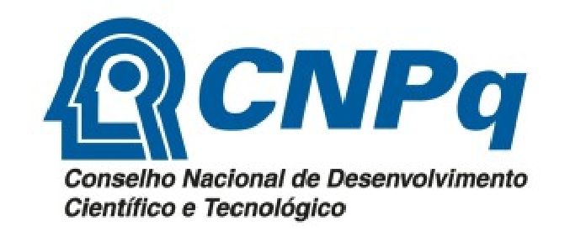 | The National Council for Scientific and Technological Development (CNPq), Brasilia, Brazil – www.cnpq.br – is a foundation linked to the Brazilian Ministry of Science and Technology. CNPq is one of the major public institutions supporting science, technology and innovation in Brazil and contributes directly to the training of researchers – masters, doctors and specialists – in the various fields of knowledge.
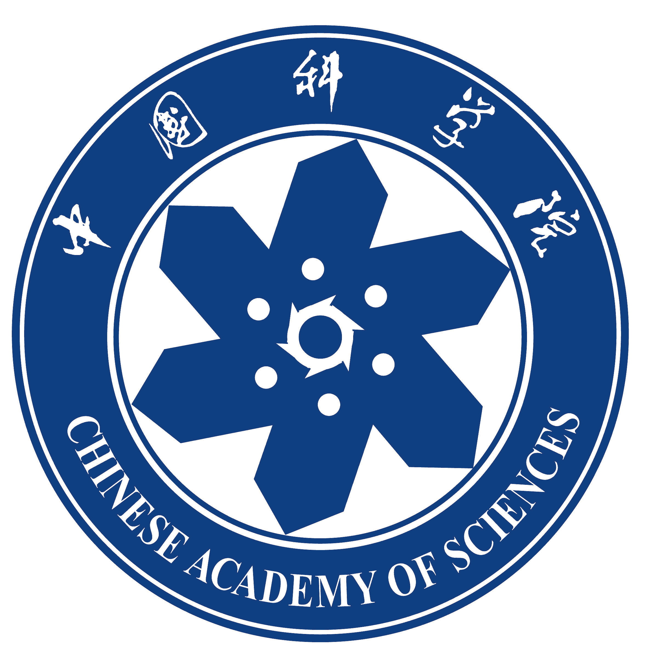 | The Chinese Academy of Sciences (CAS), Beijing, China – www.cas.ac.cn– is the highest academic institution and national comprehensive research and development centre in natural sciences and high-tech innovation in China. CAS also serves as the supreme national advisory body on science and technology. CAS has more than 80 research institutes and one university and one graduate school distributed throughout the country.
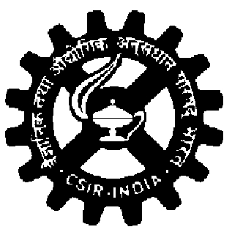 | The Council of Scientific and Industrial Research (CSIR), India – www.csir.res.in – is the Indian government's main research and development organization. It consists of a network of 38 institutes and laboratories and 39 outreach centres covering most areas of science and technology.
 | The Department of Biotechnology (DBT) of the Ministry of Science and Technology, India – www.dbt.gov.in – sponsors research in biotechnology at a number of centres of excellence in India, including university departments and CSIR institutes and laboratories.
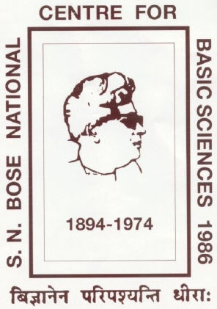 | The S.N. Bose National Centre for Basic Sciences, India – www.bose.res.in – was established in Kolkata in 1986 as an autonomous institution by the Department of Science and Technology of the government of India. It has some 36 faculty and scientists active in many areas of physics.
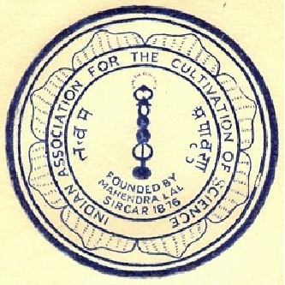 | The Indian Association for the Cultivation of Science (IACS), India – www.iacs.res.in – established in 1876 in Kolkata, is the oldest institute in India devoted to the pursuit of fundamental research in the frontier areas of basic sciences (chemistry and physics).
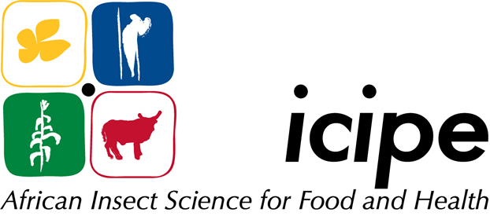 | The International Centre of Insect Physiology and Ecology (icipe), Kenya – www.icipe.org – based in Nairobi, is a research institute focused on integrated control methodologies for crop and livestock insect pests and other related arthropods, and insect vectors of tropical diseases.
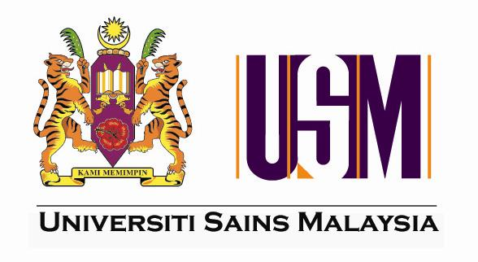 | The Universiti Sains Malaysia (USM) – www.ips.usm.my– is a worldwide renowned institution of higher education that offers courses at undergraduate and postgraduate levels to approximately 20,000 students at 24 schools and 33 centres located in three university campuses.
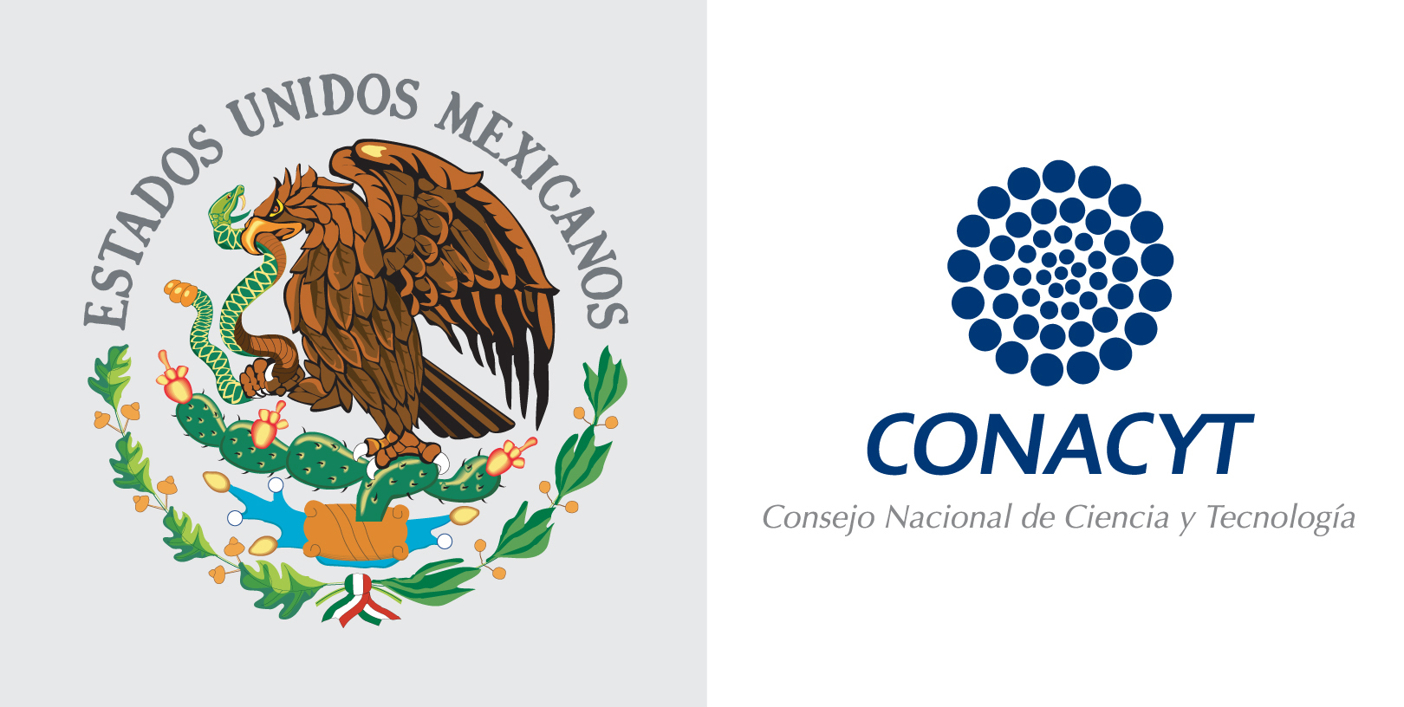 | The National Council on Science and Technology (CONACYT), Mexico - www.conacyt.mx - aims to promote the scientific development and technological modernization of Mexico through developing high level human resources, promoting and maintaining specific research projects, and disseminating scientific and technological information.
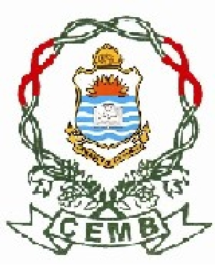 | The National Centre of Excellence in Molecular Biology (CEMB), Pakistan – www.cemb.edu.pk – based in Lahore, has expertise in plant and medical molecular biology and molecular genetics.
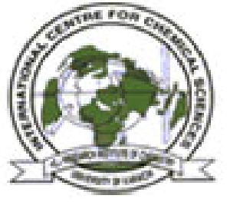 | The International Center for Chemical and Biological Sciences (ICCBS), Pakistan – www.iccs.edu – based in Karachi, comprises the H.E.J. Research Institute of Chemistry and the Dr. Panjwani Center for Molecular and Drug Research.
 | The National Center for Genetic Engineering and Biotechnology (BIOTEC), Thailand – www.biotec.or.th - founded in 1983, is a premiere research institute in Thailand and the region, with over 30 laboratories and 150 principle scientists conducting basic and applied research covering a wide spectrum from agricultural science to biomedical science and environmental science.
TWAS is grateful for the administrative and financial support provided by the above organizations in the implementation of the various collaborative fellowship programmes.
TWAS also acknowledges the financial support of the Government of Italy.

